Experiment 7

AIM: Develop Feedback Management Module using MVC Layout, Partial

View & Validation

(HTML Helpers, Validation, Layouts)

Source: Practical7.cs

Code:
FeedbackController.cs
using Microsoft.AspNetCore.Mvc;
using FeedbackManagement.Models;
namespace FeedbackManagement.Controllers
{
public class FeedbackController : Controller
{
public IActionResult Index()
{
return View();
}
[HttpGet]
public IActionResult Create()
{
return View();
}
[HttpPost]
public IActionResult Create(Feedback feedback)
{
if (ModelState.IsValid)
{
TempData["Message"] =
"Feedback submitted successfully!";
return RedirectToAction("Index");
}
return View(feedback);
}
}
}

HomeController.cs
using System.Diagnostics;
using FeedbackManagement.Models;
using Microsoft.AspNetCore.Mvc;
namespace FeedbackManagement.Controllers
{
public class HomeController : Controller
{
private readonly ILogger<HomeController> _logger;
public HomeController(ILogger<HomeController> logger)
{
_logger = logger;
}
public IActionResult Index()
{
return View();
}
public IActionResult Privacy()
{
return View();
}
[ResponseCache(Duration = 0, Location = ResponseCacheLocation.None, NoStore = true)]
public IActionResult Error()
{
return View(new ErrorViewModel { RequestId = Activity.Current?.Id ?? HttpContext.TraceIdentifier });
}
}
}

Feedback.cs
using System.ComponentModel.DataAnnotations;
namespace FeedbackManagement.Models
{
public class Feedback
{
[Required(ErrorMessage = "Name is required.")]
[StringLength(50)]
[Display(Name = "Student Name")]
public string Name { get; set; }
[Required(ErrorMessage = "Email is required.")]
[EmailAddress(ErrorMessage = "Enter a valid email.")]
[Display(Name = "Email")]
public string Email { get; set; }
[Required(ErrorMessage = "Please select a course.")]
[Display(Name = "Course")]
public string Course { get; set; }
[Required(ErrorMessage = "Please select a rating.")]
[Display(Name = "Rating")]
public string Rating { get; set; }
[Required(ErrorMessage = "Comments are required.")]
[StringLength(500, MinimumLength = 10,
ErrorMessage = "Comments must be at least 10 characters.")]
public string Comments { get; set; }
}
}

views--Feedback--Create.cshtml

@model FeedbackManagement.Models.Feedback
@{
ViewData["Title"] = "Feedback Form";
}
<h2>Feedback Form</h2>
<form asp-action="Create" method="post">
<div asp-validation-summary="ModelOnly"></div>
<p>
<label asp-for="Name"></label><br />
<input asp-for="Name" />
<span asp-validation-for="Name"></span>
</p>
<p>
<label asp-for="Email"></label><br />
<input asp-for="Email" />
<span asp-validation-for="Email"></span>
</p>
<p>
<label asp-for="Course"></label><br />
<select asp-for="Course">
<option value="">-- Select Course --</option>
<option value="Computer Engineering">
Computer Engineering
</option>
<option value="Information Technology">
Information Technology
</option>
<option value="Computer Science">
Computer Science
</option>
<option value="Electronics">
Electronics
</option>
</select>
<span asp-validation-for="Course"></span>
</p>
<p>
<label asp-for="Rating"></label><br />
<select asp-for="Rating">
<option value="">-- Select Rating --</option>
<option value="Excellent">Excellent</option>
<option value="Very Good">Very Good</option>
<option value="Good">Good</option>
<option value="Average">Average</option>
<option value="Poor">Poor</option>
</select>
<span asp-validation-for="Rating"></span>
</p>
<p>
<label asp-for="Comments"></label><br />
<textarea asp-for="Comments"
rows="5"
cols="40"></textarea>
<br />
<span asp-validation-for="Comments"></span>
</p>
<p>
<input type="submit" value="Submit Feedback" />
<a asp-controller="Feedback"
asp-action="Index">
Back
</a>
</p>
</form>
<partial name="_FeedbackInfo" />
@section Scripts {
@{
await Html.RenderPartialAsync("_ValidationScriptsPartial");
}
}

views--Feedback--Index.cshtml
@{
ViewData["Title"] = "Feedback Management";
}
<h2>Feedback Management</h2>
@if (TempData["Message"] != null)
{
<p>
<strong>@TempData["Message"]</strong>
</p>
}
<p>
This module allows students to submit their feedback.
</p>
<p>
<a asp-controller="Feedback"
asp-action="Create">
Give Feedback
</a>
</p>

view--Shared--Feedbackinfo.cshtml

<h3>Feedback Information</h3>
<p>Please enter your details and submit your feedback.</p>
<ul>
<li>Name and email are required.</li>
<li>Select your course.</li>
<li>Select a rating.</li>
<li>Enter your comments.</li>
</ul>

view--Shared--Layout.cshtml
<!DOCTYPE html>
<html lang="en">
<head>
<meta charset="utf-8" />
<meta name="viewport" content="width=device-width, initial-scale=1.0" />
<title>@ViewData["Title"] - FeedbackManagement</title>
<link rel="stylesheet" href="~/lib/bootstrap/dist/css/bootstrap.min.css" />
<link rel="stylesheet" href="~/css/site.css" asp-append-version="true" />
<link rel="stylesheet" href="~/FeedbackManagement.styles.css" asp-append-version="true" />
</head>
<body>
<header>
<nav class="navbar navbar-expand-sm navbar-toggleable-sm navbar-light bg-white border-bottom box-shadow mb-3">
<div class="container-fluid">
<a class="navbar-brand" asp-area="" asp-controller="Home" asp-action="Index">FeedbackManagement</a>
<button class="navbar-toggler" type="button" data-bs-toggle="collapse" data-bs-target=".navbar-collapse" aria-controls="navbarSupportedContent"
aria-expanded="false" aria-label="Toggle navigation">
<span class="navbar-toggler-icon"></span>
</button>
<div class="navbar-collapse collapse d-sm-inline-flex justify-content-between">
<ul class="navbar-nav flex-grow-1">
<li class="nav-item">
<a class="nav-link text-dark"
asp-controller="Home"
asp-action="Index">
Home
</a>
</li>
<li class="nav-item">
<a class="nav-link text-dark"
asp-controller="Feedback"
asp-action="Index">
Feedback
</a>
</li>
</ul>
</div>
</div>
</nav>
</header>
<div class="container">
<main role="main" class="pb-3">
@RenderBody()
</main>
</div>
<footer class="border-top footer text-muted">
<div class="container">
&copy; 2026 - FeedbackManagement - <a asp-area="" asp-controller="Home" asp-action="Privacy">Privacy</a>
</div>
</footer>
<script src="~/lib/jquery/dist/jquery.min.js"></script>
<script src="~/lib/bootstrap/dist/js/bootstrap.bundle.min.js"></script>
<script src="~/js/site.js" asp-append-version="true"></script>
@await RenderSectionAsync("Scripts", required: false)
</body>
</html>

Program.cs

var builder = WebApplication.CreateBuilder(args);
// Add services to the container.
builder.Services.AddControllersWithViews();
var app = builder.Build();
// Configure the HTTP request pipeline.
if (!app.Environment.IsDevelopment())
{
app.UseExceptionHandler("/Home/Error");
// The default HSTS value is 30 days. You may want to change this for production scenarios, see https://aka.ms/aspnetcore-hsts.
app.UseHsts();
}
app.UseHttpsRedirection();
app.UseStaticFiles();
app.UseRouting();
app.UseAuthorization();
app.MapControllerRoute(
name: "default",
pattern: "{controller=Home}/{action=Index}/{id?}");
app.Run();

Output:

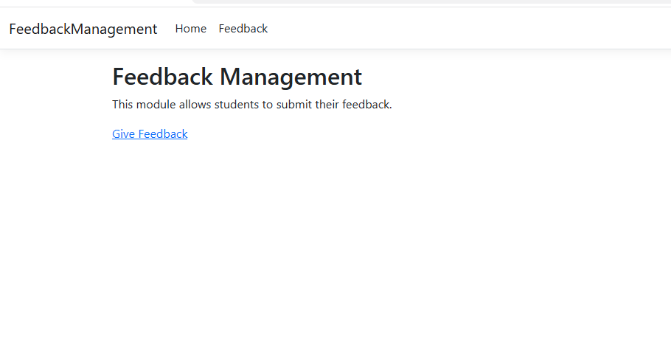

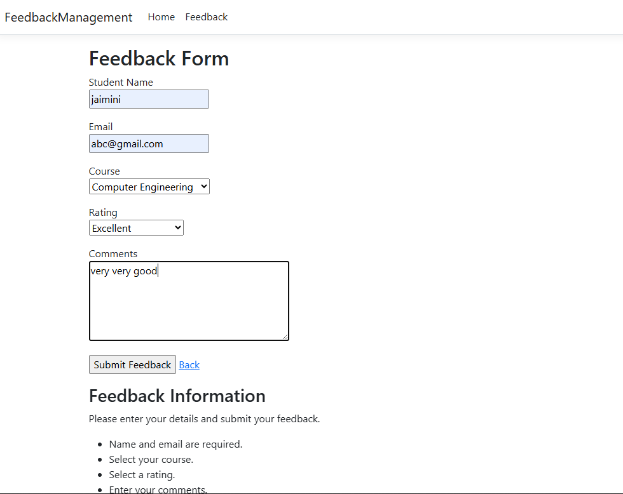

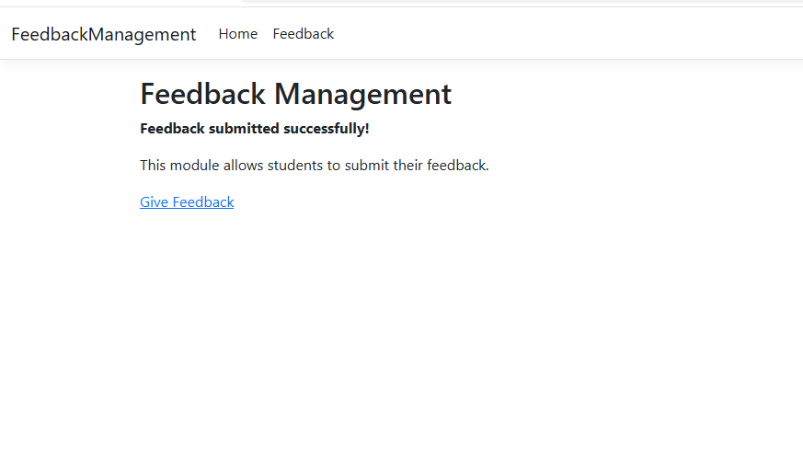

GitHub URL.: https://jaiminitundiya129700-spec.github.io/.NET-Practical-6/

